Name:
Classwork
Review

Topic: Verb To be.
The weather

Objectives:  To review verb to be.  To review vocabulary related to the weather.  To write affirmative sentences related to the weather. | Ideal Score: 24
 | Real Score:
 | Mark:

Before working on this worksheet, please go to https://www.youtube.com/watch?v=CXKj7bm4Ops&t=146s

To be
/12

Negative
Affirmative

I’m not
You aren’t
He isn’t
She isn’t
It isn’t
We aren’t
They aren’t
I am
You are
He is
She is
It is
We are
They are

II. What’s the negative?
Complete with am not - isn’t - aren’t.

- They..........................so fast.
- I........................tall.
- She........................my sister.
- We........................present.
- You........................hungry.
- I........................angry.

- Let’s do the following exercises!

Complete with verb to be.

- I........................a student.
- She........................my best friend.
- You........................a nice person.
- It........................black and white.
- We........................in the classroom.
- He........................really handsome.

Let’s remember some vocabulary related to the weather.
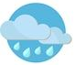

SUNNY
RAINY / RAINING
WINDY

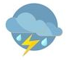
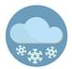

STORMY
SNOWY / SNOWING
CLOUDY

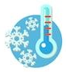
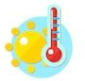

COLD
HOT

/6
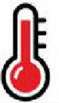
III. Look at the drawings and complete with the vocabulary given.

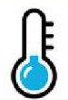
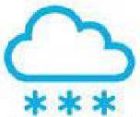

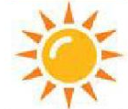

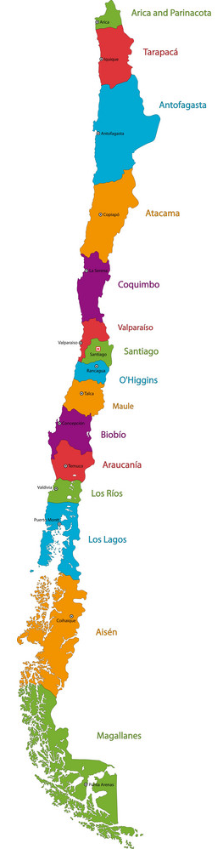
/6
IV. Look at the map and answer.
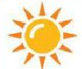
How’s the weather in Vaparaíso?
It’s sunny.

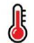
How’s the weather in Tarapacá?
It’s..............................................

How’s the weather in Aisén?
.....................................................

How’s the weather in Antofagasta?
......................................................

How’s the weather in Atacama?
......................................................
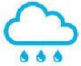
How’s the weather in Magallanes?
......................................................

How’s the weather in Biobio?
......................................................

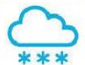

IMPORTANT!

Please send this worksheet back to my e-mail by: Tuesday 24th .
jparedes@greenhillcollege.cl

Well. That’s all (for now).
I hope to see you soon (I really do).
Take care of yourselves and pay attention to what your parents say to you.
See you!

