Name:
Classwork
Review

Topic: Personal Pronouns.
Verb To be.

Objectives:  To review Personal Pronouns.  To review verb to be. | Ideal Score: 26
 | Real Score:
 | Mark:

Before working on this worksheet, please go to
https://www.youtube.com/watch?v=cVkSndpZtN0

Personal Pronouns
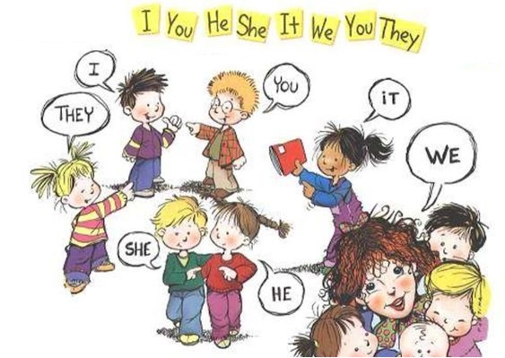
I
You
He
She
It
We
You
They

- What’s the correct Personal Pronoun?
Write the correct personal pronoun according to the noun.
(¿Cuál es el pronombre personal correcto?
Escribe el pronombre personal de acuerdo al sustantivo)

Example: My mom : She
/4

- The dog :

- My brother :

- Pedro and María :

- The cat :

/10
- Classify the following words into the correct Personal Pronoun.
(Clasifica las siguientes palabras en la columna que corresponda)

my sister a house Pedro Alicia my canary
dad Jorge and Pamela a car Juan Sonia

He | She | It | They

Let’s remember verb to be!
(¡Recordemos el verbo be = ser o estar!)

Look at the chart.
(Observa el cuadro)
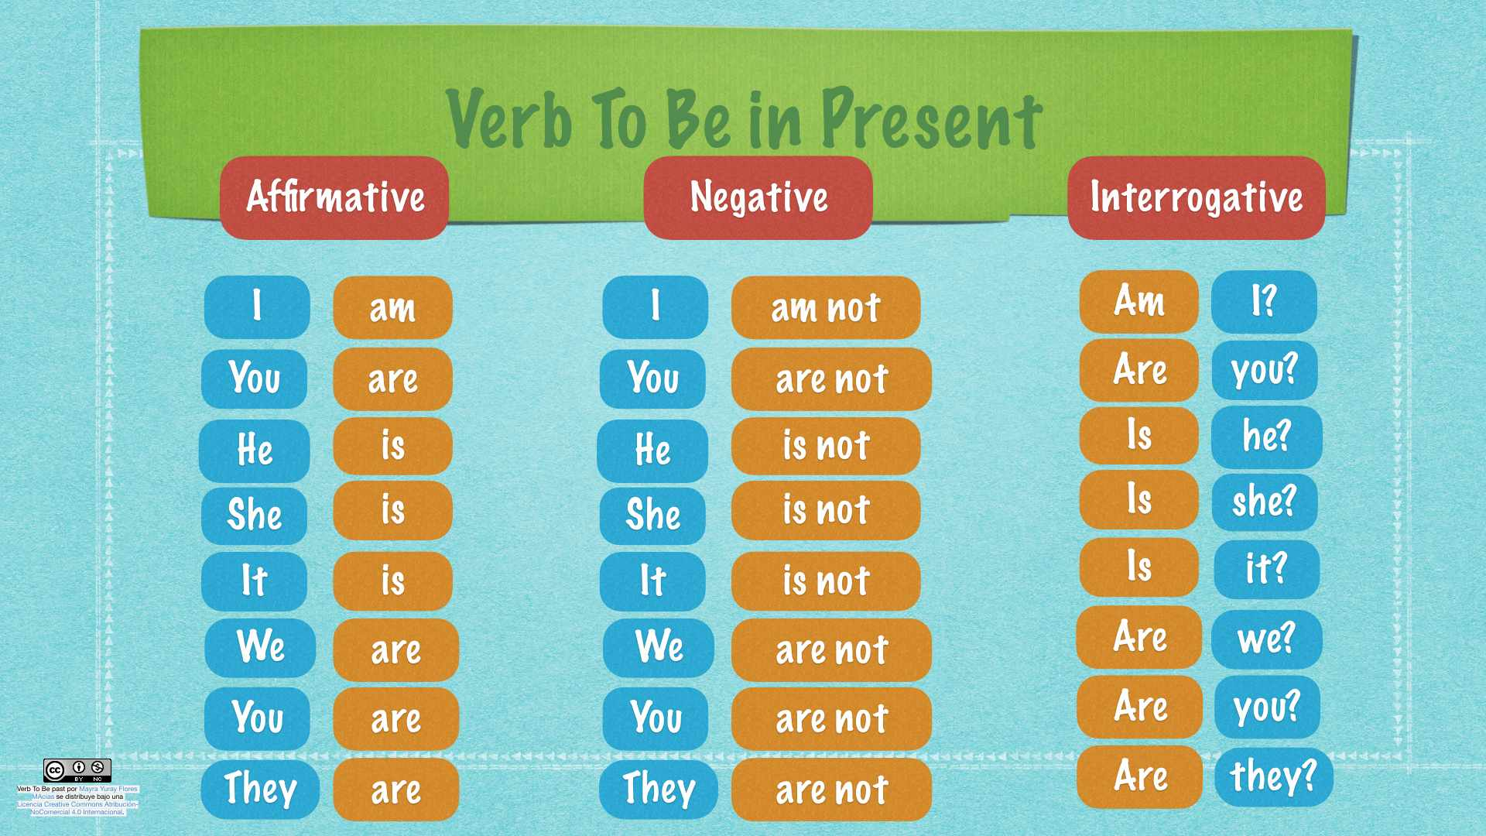

Now let’s practise verb to be.
(Ahora practiquemos el verbo to be)

- Complete the sentences with am - is - are .
(Completa las oraciones con am - is - are donde corresponda)
/6

- She my mom.

- I ten years old.

- We in the classroom.

- He from Chile.

- They best friends.

- I a doctor.

- Complete the sentences using am not - is not - are not .
(Completa las oraciones usando el negativo am not - is not -
are not donde corresponda.)

/6

- You present.

- He my brother.

- I hungry.

- We scientists.

- It so big!

- She at home.

IMPORTANT!

Please send this worksheet back to my e-mail by: Tuesday 24th
(Por favor enviar está guía hasta el día miércoles 25 de marzo al correo de abajo)

jparedes@greenhillcollege.cl

Well. That’s all (for now).
I hope to see you soon (I really do).
Take care of yourselves and pay attention to what your parents say to you.
See you!

