GREENHILL
COLLEGE

Profesor asignatura: Angel Villarroel. Worksheet ONE

tOPICTopic:
CLASS: CUARTO MEDIO
Objectivo: Revisar y reforzar las frases condicionales Zero, Primera, Segunda y Tercera describiendo una situación hipotética. Enfatizar el uso de verbos regulares e irregulares en pasado simple y participio. | Student’s Score:
Total Score:
53 points
 | Mark:

Third Conditional sentences
- Look at the pictures and write some third conditional sentences : (20 points)

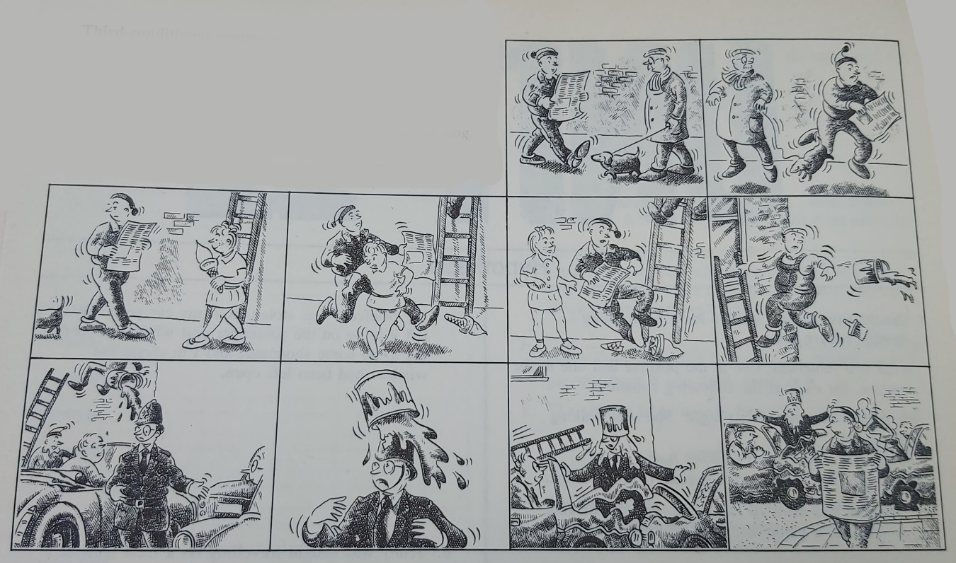

If the man had been looking where he was going, instead of reading a newspaper, he would have seen the dog and wouldn’t have tripped over it. If he hadn’t been looking.......................................
________________________________________________________________________________________________________________________________________________________________________________________________________________________________________________________________________________________________________________________________________________________________________________________________________________________________________________________________________________________________________________________________________________________________________________________________________________________________________________________________________________________________________________________________________________________________________________________________________________________________________________________________________________________________________________________________________________________________________________________________________________________________________________________________________________________________________________________________________________________________________________________________________________________________________________________________________________________________________________________________
________________________________________________________________________________________________________________________________________________________________________________________________________________________________________________________________________________________________________________________________________________________________________________________________________________________________________________________________________________________________________________________________________________________________________________________________________________________________________________________________________________________________________________________________________________________________________________________________________________________________

- First , Second , third , and zero conditionals (33 points)
Put the verbs in brackets in the correct forms. There are examples of first, second and third conditionals, and the zero conditional as well.
- If you ___________________________(go) away, you___________________(write) to me, won’t we?
- Unless house plants _________________________(water) regularly, they ________________________________(die) quite quickly.
- What noisy neighbours you’ve got! If mine _____________________(be) as bad as yours, I ________________________(go) crazy!
- You’re late again ! If you ___________________________(be) late again tomorrow, your pay ________________________(stop)!
- The passengers at the front of the plane were all killed, but Alice, who was sitting at the back, survived. If she ____________________________(sit) nearer the front, she _____________________________(kill).
- I eat meat once or twice a day, but I ____________________________(not like) it if it _________________________________(undercook).
- Eat your soup. If you _______________________________(not hurry) up, it _____________________________________(get) cold.
- There are mice in your kitchen. If you ___________________________(have) a cat, the mice ________________________________(disappear) immediately.
- The style of that dress is lovely, but I’m not so keen on the colour. If the blue __________________________(be) a bit lighter, it _______________________(look) better.
- A: We are penniless. Did you know that?
B: It’s because our holiday cost so much. You should have listened to me. If we _________________________________ (go) where I wanted to go, it __________________________________(be) a lot cheaper. And we _________________________(have) some money in the bank now.
- She was badly. Hurt when the car in which she was a passenger hit another car. If she ______________________(wear) her seat belt, she _________________________(not hurt) so badly.
- Give me that message for Peter. If I _____________________________(see) him this afternoon, I _________________________(give) it to him.
- Mmmm! This meal’s delicious ! If I _________________________(can) cook as well as this, I __________________________(open) a restaurant.
- My wife and I met on a course. I was on it because I was recovering from an illness, and she was the ship’s doctor. Just think! If I ___________________________(not be) ill, and if she _______________________________(not be) the doctor, we __________________________(not meet), we ____________________________(not get) married, and our children ________________________________(not be) born! What a thought!
- If you ______________________________(be able) to do this exercise, you _______________________________(be) very clever!

