WORKSHEET 1
HELLO! What’s your name?
Name: 3rd grade Deadline: 24-03-2020
Code class: VJ3eH3 6pm
ACTIVITY 1.
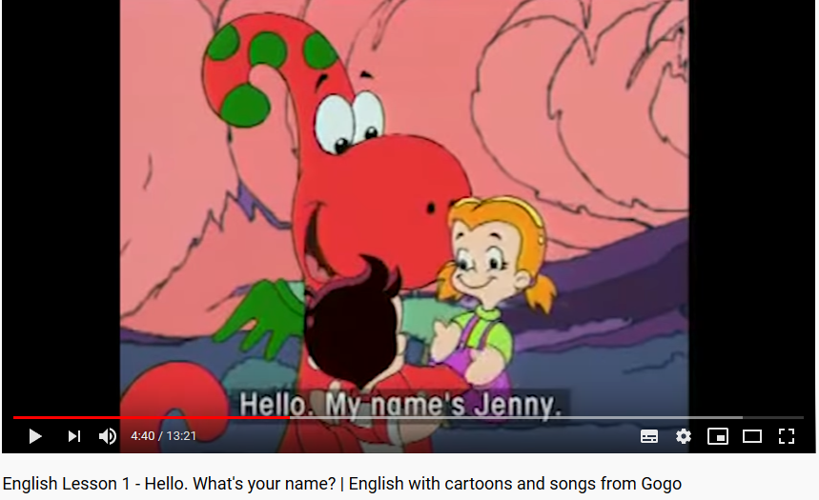
1. Go to the link https://www.youtube.com/watch?v=7k4uBAiJsMM English lesson 1. and WATCH IT!
2. Answer the following questions:
What’s your name? ________________

What’s his name? ____________

Name all the names in the video
- - -
- - -
3. Create a dialogue like the one you heard. (Crea un diálogo como el que oíste en el video) máx 6 interacciones u tilizando las siguientes palabras. (Ten cuidado porque están desordenadas)
How are you? – Hello – What’s your name? – I’m …. – I’m fine – thank you

______________________________________________________________________________________________________________________________________________________________________________________________________________________________________________________________________________
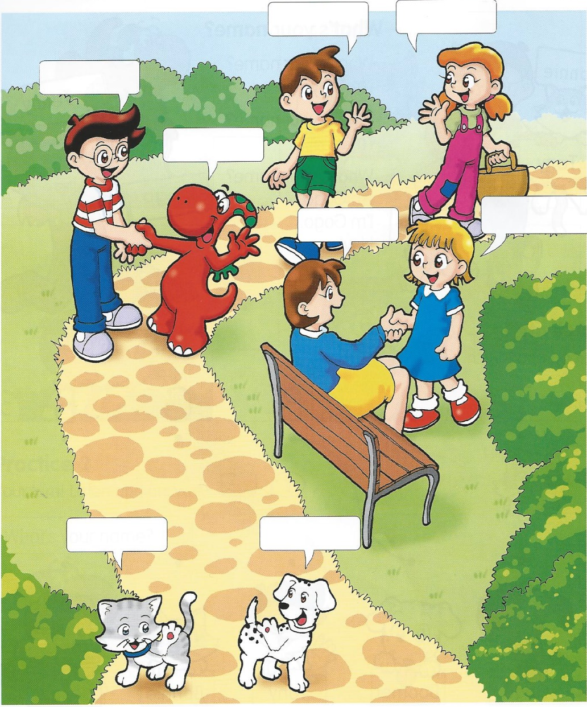
4. Finally, write in the balloons what you think they’re saying. Escribe lo que crees que están diciendo.

